**Report On OSI Model:-**

*It was established in 1947, the International Standards Organization (ISO) is a multinational body dedicated to worldwide agreement on international standards. An ISO standard that covers all aspects of network communications is the Open Systems Interconnection (OSI) model. It was first introduced in the late 1970s.*

*Basically, the OSI model is used to know how data is transferred from one computer to another.*

***ISO is the organization. OSI is the model.***

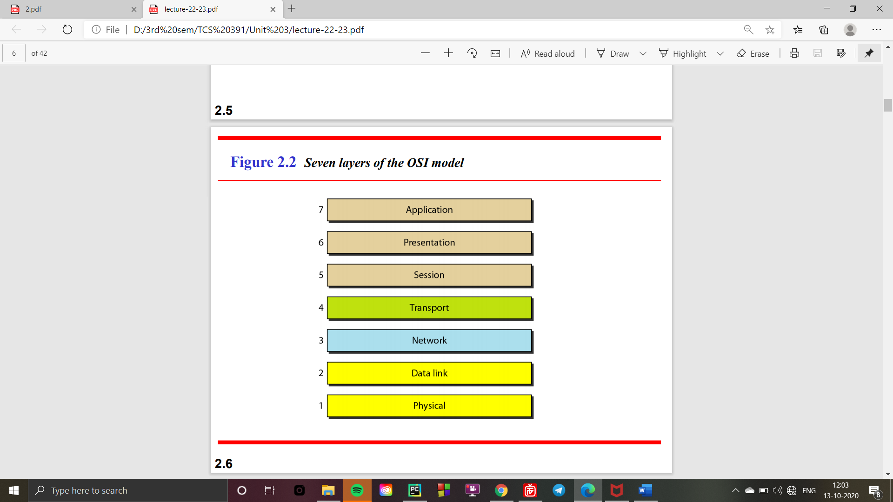

***APPLICATION LAYER:-***

* ***Application Layer provides services for network application with the help of protocols to perform user activities.***
* ***For file transfer(FTP)***
* ***For emails(SMTP)***
* ***For Web Surfing http/https***
* ***For Virtual Terminals(Telnet)***

*Presentation layer:-*

* *It receives data from application layer.*
* *It is is responsible for translation, compression, and encryption.*

***Session layer:-***

* ***It helps setting up Network Authentication and Authorization. (i.e***  *for dialog control and synchronization*)

***Transport layer:-***

* ***It controls reliability of communication through-segmentation-flow control-error control,i.e*** *for the delivery of a message from one process to another****.***

***Network layer:-***

* ***It works for the transmission of data from one host to other, located in different networks, i.e*** *for the delivery of individual packets from the source host to the destination host.*

***Data link layer:-***

* ***It is responsible for the node delivery message, i.e****. for moving frames from one hop (node) to the next*.

***PHYSICAL LAYER:-***

* *The physical layer is responsible for movements of individual bits from one hop (node) to the next.*